FAQFlow AI: Conversational Support Generator

Project Description:

1. Project Overview :
FAQFlow AI is an AI-powered conversational support system designed to transform static FAQ documents into an intelligent and interactive chatbot experience. The system enables users to ask questions in natural language and receive accurate, context-aware responses generated using Retrieval-Augmented Generation (RAG).
The platform works by converting FAQ data into vector embeddings and storing them in a vector database. When a user submits a query, the system retrieves the most relevant FAQ entries and uses a language model to generate a conversational response.
Unlike traditional FAQ systems, this project not only retrieves answers but also suggests follow-up questions and maintains short-term conversation memory, making the interaction more dynamic and user-friendly.

2. Problem Statement :
Most existing FAQ systems are static and require users to manually search for answers, which is inefficient and time-consuming. These systems lack conversational capabilities and fail to provide contextual or personalized responses.
There is a need for an intelligent support system that can:
- Understand user queries
- Retrieve relevant information automatically
- Provide conversational responses
- Enhance customer experience through interactive support

3. Objectives :
- The primary objective of this project is to develop an AI-driven FAQ support system that enables dynamic and conversational interaction using Retrieval-Augmented Generation (RAG).
- Another key objective is to implement semantic search using embeddings and vector databases to accurately retrieve relevant FAQ entries based on user queries.
- The project also focuses on integrating a lightweight language model to generate human-like responses strictly based on retrieved context, ensuring accuracy and reliability.
- Additionally, the system aims to provide follow-up suggestions and maintain short-term session memory to improve user engagement and interaction quality.

4. Core Technologies Used

Technology | Purpose
Python | Backend logic and AI processing
FastAPI | API development and request handling
FAISS | Vector database for similarity search
Sentence Transformers (MiniLM) | Text embedding generation
Transformers (FLAN-T5) | Response generation
HTML, CSS, JavaScript | Frontend chatbot interface

5. Key Features

FAQ Retrieval System
- Retrieves relevant FAQ answers using semantic similarity search
- Uses FAISS for fast and efficient retrieval

Conversational Response Generation
- Generates natural, human-like responses using FLAN-T5
- Ensures answers are based strictly on retrieved context

Follow-up Suggestions
- Provides basic follow-up suggestions based on retrieved FAQ entries
- Improves user exploration and interaction

Short-Term Memory
- Supports limited context handling within a single query-response cycle
- Enables context-aware responses

Modern Chat Interface
- Clean UI with glassmorphism design
- Interactive and user-friendly chatbot experience

6. Target Users
- Customers seeking automated support
- Businesses aiming to improve customer experience
- Websites requiring intelligent FAQ systems
- Helpdesk and support platforms

7. Real-World Applications

This system enhances traditional FAQ systems by making them interactive, intelligent, and user-friendly.

APPLICATION SCENARIOS / USE CASES :

Scenario 1:Customer Support Automation
A user asks a question like “How to reset password?”. The system retrieves the relevant FAQ entry and generates a conversational response. It also suggests related questions such as “How to change email?” or “How to update profile?”.

Scenario 2: Website Help Assistant
Users browsing a website can interact with the chatbot instead of searching through long FAQ pages, improving accessibility and user experience.

Scenario 3: Technical Support System
The chatbot can assist users in troubleshooting issues by providing instant answers from the FAQ dataset.

TECHNICAL ARCHITECTURE :

● Frontend Layer
The frontend provides a chatbot interface built using HTML, CSS, and JavaScript. It allows users to enter queries and view responses along with suggested follow-up questions.

● Backend Layer
The backend is developed using FastAPI and handles query processing, embedding generation, retrieval, and response generation.

● RAG Pipeline
The system follows a Retrieval-Augmented Generation approach:
- Convert user query into embeddings
- Perform similarity search in FAISS
- Retrieve relevant FAQ entries
- Pass retrieved context to LLM
- Generate final response

● Database Layer
Data Storage Layer: FAQ data is stored in a CSV file and converted into embeddings for retrieval using FAISS.

● External APIs / Services
The system uses pre-trained models such as Sentence Transformers for embeddings and FLAN-T5 for response generation.

● Deployment Environment
The system runs locally with backend hosted via FastAPI and frontend accessed through a web browser.

Pre-requisites:
Software Requirements
- Python 3.x
- FastAPI, Uvicorn
- Sentence Transformers
- FAISS
- Transformers
- Web browser

Libraries / Frameworks / Dependencies
pip install pandas fastapi uvicorn sentence-transformers faiss-cpu transformers torch

Hardware Requirements
- Minimum 8GB RAM
- CPU sufficient for model inference

PRIOR KNOWLEDGE REQUIRED

Programming Language Knowledge
- Strong understanding of Python fundamentals (variables, loops, functions, modules)
- Basic knowledge of object-oriented programming (OOP) concepts
- Familiarity with handling JSON data and API responses
- Understanding of basic error handling and debugging

Framework Basics
- Understanding of FastAPI for building REST APIs
- Knowledge of API routing, request/response handling
- Basic idea of asynchronous programming (async/await)
- Familiarity with running servers using Uvicorn

- Data Handling & Storage
- Basic knowledge of working with CSV files for storing FAQ data
- Understanding how structured data (question-answer pairs) is stored and processed
- Familiarity with data preprocessing techniques

Networking Concepts
- Understanding of client-server architecture
- Basic knowledge of REST APIs and HTTP methods (GET, POST)
- Understanding how frontend communicates with backend APIs

- AI / ML Fundamentals
- Basic understanding of Natural Language Processing (NLP)
- Knowledge of text embeddings and semantic similarity
- Understanding of Retrieval-Augmented Generation (RAG)
- Familiarity with pre-trained models like:
- Sentence Transformers (MiniLM)
- FLAN-T5
- Basic awareness of how LLMs generate responses from given context

8. PROJECT OBJECTIVES

Technical Objectives
- Design and develop an AI-powered FAQ chatbot using RAG architecture
- Implement semantic search using embeddings and FAISS vector database
- Build a system that retrieves relevant FAQ entries based on user queries
- Integrate FLAN-T5 model for generating conversational responses
- Develop REST API (/chat) using FastAPI for handling user queries
- Implement short-term memory for better conversational flow
- Provide follow-up question suggestions to enhance user interaction

Performance Objectives
- Relatively fast response times for small to medium FAQ datasets
- Optimize embedding generation and retrieval process
- Maintain lightweight model usage for faster inference
- Provide accurate responses strictly based on FAQ dataset

Deployment Objectives
- Enable local deployment using FastAPI and browser-based frontend
- Ensure secure handling of configurations using .env file
- Support smooth interaction between frontend and backend APIs
- Provide easy setup and execution for development environment

Learning Outcomes
- Gain hands-on experience in building AI-powered chatbot systems
- Understand implementation of RAG (Retrieval-Augmented Generation)
- Learn integration of embeddings, vector search, and LLMs
- Develop skills in API development using FastAPI
- Improve knowledge in system design, data flow, and AI-based applications

Project WorkFlow:

Milestone 1: Requirement Analysis & System Design

Activity 1.1: Problem Definition
Identify the need for an intelligent FAQ support system that can transform static FAQ documents into an interactive conversational chatbot. Traditional FAQ systems require users to manually search for answers, making the process slow and inefficient.
Design a system that:
- Understands user queries in natural language
- Retrieves relevant FAQ entries automatically
- Generates conversational responses using AI
- Enhances user experience through interactive support
The system should be scalable, user-friendly, and capable of delivering accurate responses using Retrieval-Augmented Generation (RAG).

Activity 1.2: Functional Requirements
FR-01: Allow users to enter queries through a chatbot interface
FR-02: Convert user queries into embeddings using a model
FR-03: Perform similarity search using FAISS
FR-04: Retrieve the most relevant FAQ entries from dataset
FR-05: Generate conversational responses using FLAN-T5
FR-06: Provide follow-up question suggestions
FR-07: Maintain short-term conversation memory within session
FR-08: Provide API endpoint (/chat) for handling queries

Activity 1.3: Non-Functional Requirements
NFR-01 Performance: Fast response using efficient vector search
NFR-02 Reliability: Accurate answers based on FAQ dataset
NFR-03 Scalability: Ability to handle more FAQs and queries
NFR-04 Security: API keys and configs stored in .env
NFR-05 Maintainability: Modular structure (RAG pipeline, API, UI)
NFR-06 Usability: Simple chatbot interface for easy interaction

Activity 1.4: System Design Decisions & Technology Stack Selection
Backend Framework: FastAPI
Vector Database: FAISS
Embedding Model: Sentence Transformers MiniLM
LLM: FLAN-T5
Frontend: HTML, CSS, JavaScript
Architecture:
User Query → Embedding → FAISS Search → Retrieve FAQ → LLM → Response
Data Storage:
- FAQ stored in CSV file (faqs.csv)
- Converted into embeddings for retrieval

Design Approach:
- RAG-based system
- API-first design
- Modular pipeline (embedding + retrieval + generation)

Milestone 2: Environment Setup & Initial Configuration

Activity 2.1:Development Setup
- Install Python 3.x
- Use VS Code or any IDE
- Create virtual environment
- Activate environment

Activity 2.2: Dependency Installation
pip install pandas fastapi uvicorn sentence-transformers faiss-cpu transformers torch

Activity 2.3: Project Structure
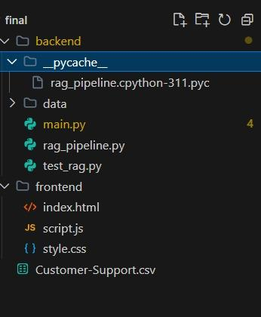

Activity 2.4: Configuration Setup
- Store configurations in .env file
- Include API keys if needed
- Initialize models and FAISS index

Milestone 3:Data Preparation

- Activity 3.1: Prepare FAQ Dataset

- Store FAQ data in CSV format:

Question, Answer
How to reset password?, Click on forgot password...

- Activity 3.2: Generate Embeddings

- Convert FAQ text into vectors using MiniLM
- Store embeddings in FAISS index

Milestone 4: Core System Development

Activity 4.1: RAG Pipeline
- Convert user query → embedding
- Perform similarity search
- Retrieve top FAQs

Activity 4.2:Response Generation
- Pass retrieved FAQs to FLAN-T5
- Generate conversational response

Activity 4.3: API Development
Build /chat endpoint using FastAPI
Return:
- Answer
- Follow-up suggestions

Milestone 5: Integration & Optimization

Activity 5.1: Integration

Connect frontend with backend API

Ensure smooth query-response flow

Activity 5.2: Performance Optimization

Optimize FAISS search

Use lightweight models

Activity 5.3: Error Handling

Handle irrelevant queries

Return “I don’t know” when needed

Milestone 6: Deployment

Activity 6.1: Local Deployment

The system is deployed locally without using cloud platforms or GitHub.

Steps:

1. Run backend:
uvicorn main:app --reload

2. Open frontend:
Open index.html in browser

3. Access API:
http://localhost:8000/chat

The frontend communicates with the backend API to provide chatbot responses.
The backend runs on http://localhost:8000 and processes requests from the frontend via the /chat endpoint.

PROJECT STRUCTURE

Clean Folder Structure
FAQFlow-AI/
│
├── backend/
│ ├── main.py
│ ├── rag_pipeline.py
│ └── requirements.txt
│
├── frontend/
│ ├── index.html
│ ├── style.css
│ └── script.js
│
├── data/
│ └── faqs.csv
│
├── .env
└── README.md

Folder Explanations

backend/
- Contains the core logic of the application
- Built using FastAPI
- Handles user queries and returns responses
- Implements the RAG (Retrieval-Augmented Generation) pipeline
- Manages embedding, retrieval, and response generation

backend/main.py
- Entry point of the backend application
- Defines API endpoints (e.g., /chat)
- Handles incoming requests from frontend
- Sends responses back to the user

backend/rag_pipeline.py
- Implements the core RAG workflow:
  - Convert query into embeddings
  - Perform similarity search using FAISS
  - Retrieve relevant FAQ entries
  - Generate response using FLAN-T5
- Acts as the brain of the system

backend/requirements.txt
- Lists all required Python libraries
- Example:
  - fastapi
  - uvicorn
  - sentence-transformers
  - faiss-cpu
  - transformers
  - torch

frontend/
- Contains the user interface of the chatbot
- Built using HTML, CSS, and JavaScript
- Provides an interactive chat experience
- Communicates with backend API

frontend/index.html
- Main structure of the chatbot UI
- Input field for user queries
- Displays chatbot responses

frontend/style.css
- Handles styling of the chatbot interface
- Provides clean and modern UI design

frontend/script.js
- Handles frontend logic
- Sends user queries to backend (/chat API)
- Displays responses and follow-up suggestions

data/faqs.csv
- Stores FAQ dataset in Question–Answer format
- Used as the knowledge base for retrieval
- Converted into embeddings for semantic search

.env
- Stores sensitive configuration data securely
- Includes configuration settings and optional API keys (if required for model usage). Ensures secure handling of environment-specific data.
- Prevents exposure of confidential information in code
- Supports environment-based configuration
- Essential for secure application deployment

README.md
- Contains project documentation
- Includes setup instructions and usage
- Helps others understand the project

RESULTS

● System Output
The system successfully retrieves relevant FAQ entries and generates conversational responses. It also provides follow-up suggestions to enhance user interaction.

● Performance Evaluation
The system demonstrates fast response times due to efficient vector search using FAISS and lightweight model inference.

● Screenshots
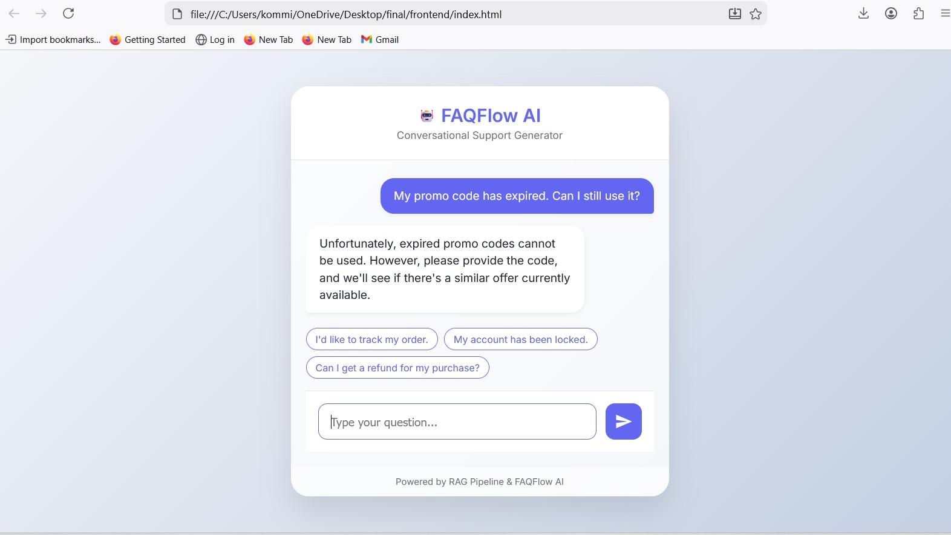
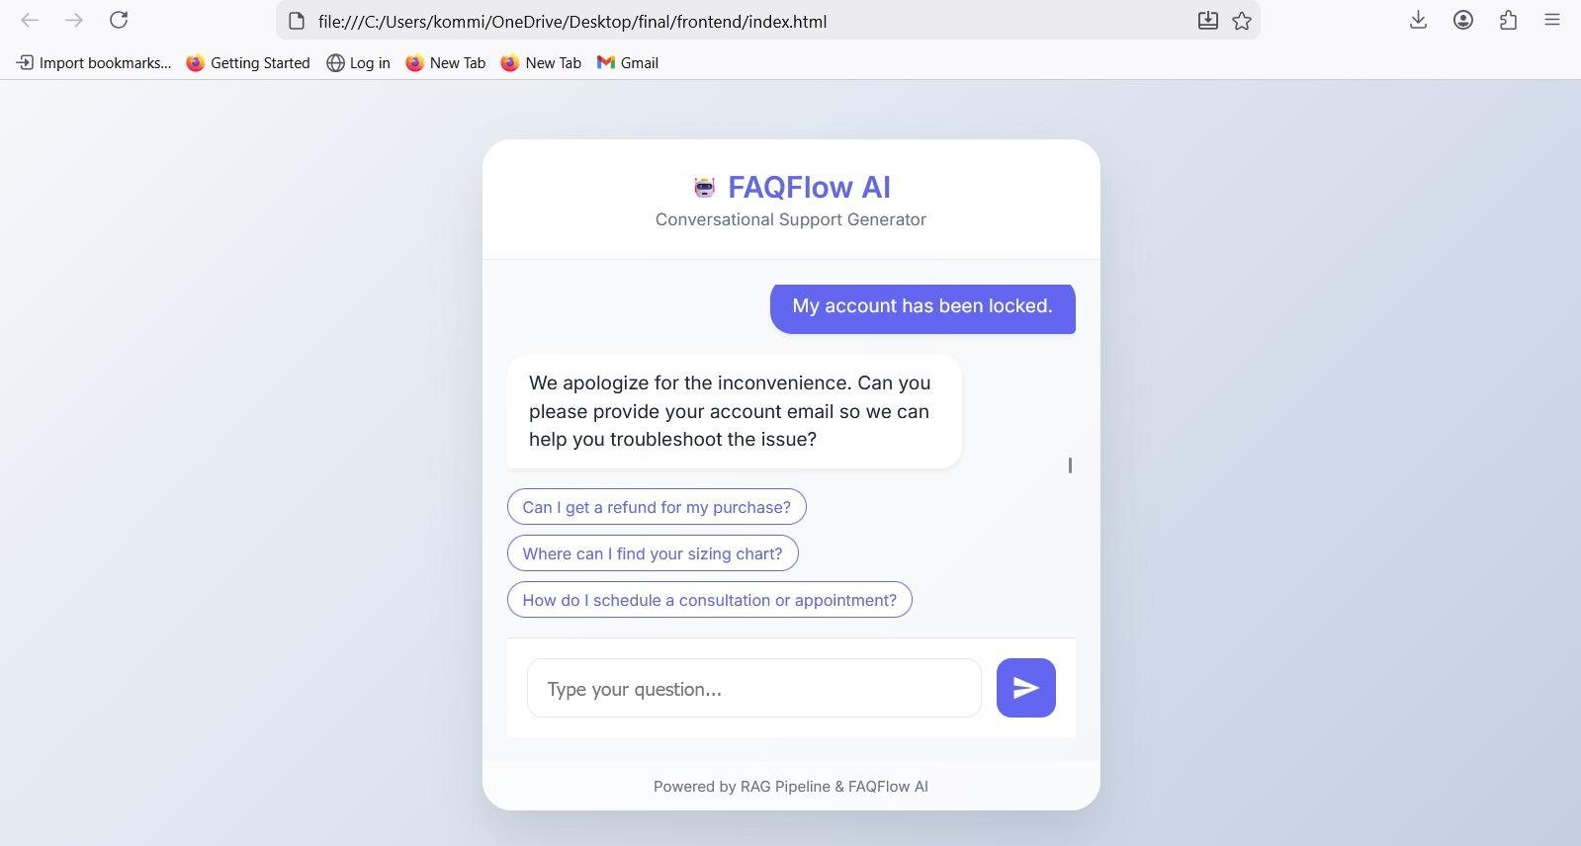

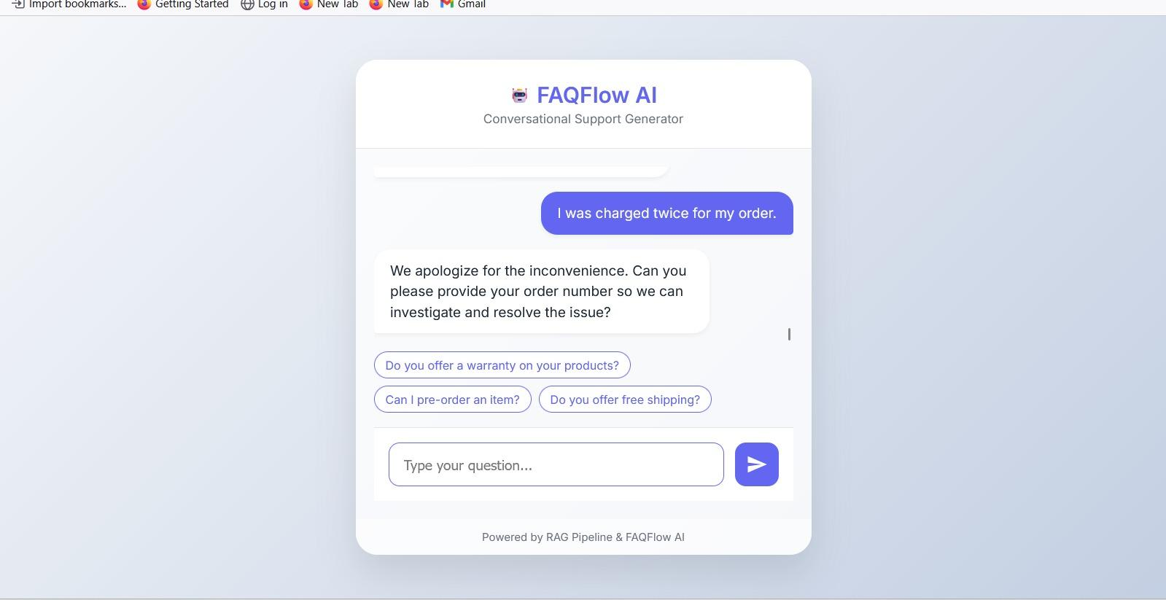

● Testing Results
- Valid queries return correct answers
- Irrelevant queries return “I don’t know”
- Follow-up suggestions improve usability

ADVANTAGES & LIMITATIONS

Advantages

Intelligent FAQ retrieval

Conversational responses

Fast and efficient

Improves customer experience

Limitations

Limited to FAQ dataset

No long-term memory

Depends on data quality

Cannot answer unrelated questions
- Performance depends on quality and size of FAQ dataset

FUTURE ENHANCEMENTS

Scalability Improvements
- Integrate cloud-based vector databases
- Optimize retrieval performance

Feature Expansion
- Add multi-language support
- Enable voice-based interaction
- Helps reduce hallucination by grounding responses in retrieved FAQ context

AI Improvements
- Use advanced LLMs for better responses
- Improve contextual memory

Deployment Enhancements
- Deploy on cloud platforms
- Integrate with real-time applications
Conclusion:
FAQFlow AI demonstrates how Retrieval-Augmented Generation can be used to enhance traditional
FAQ systems by making them interactive and intelligent. By combining vector search, embeddings,
and language models, the system provides accurate, conversational, and context-aware responses.
This project highlights the potential of AI-driven support systems in improving customer experience
and offers a scalable foundation for future development.

APPENDIX

Source Code
The project is organized into backend and frontend modules, implementing RAG pipeline, API
development, and chatbot interface.
Configuration Files
Includes .env, requirements.txt, and project setup files.
Dataset Details
FAQ dataset stored in CSV format containing question-answer pairs used for retrieval.

API Documentation
/chat → Handles user queries
Returns response + follow-up suggestions

